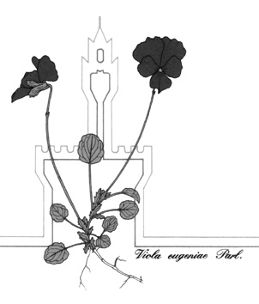

Società Botanica Italiana onlus
118° Congresso della Società Botanica Italiana onlus

IX International Plant Science Conference (IPSC)

DISCLAIMER

I, …………………………..………………………………………………………

AUTHORIZE

the Scientific Committee of the 118th Congress SBI to use
□ abstract of oral presentation/poster
□ poster in pdf and jpg format
entitled _________________________________________________________________________________
_______________________________________________________________________________________

presented during the Congress for any disclosure in paper or electronic form on internet sites of scientific interest and to be delivered to the participants during the Congress.

DECLARES

- that the contents of the presentation, images, texts, movies and more, are free from the constraints of copyright;
- that the text content is shared by all the authors indicated.

The material will be distributed free of charge without any view to profit.

Date _______________ Signature __________________________________________

Complete and submit at the time of submission of the abstract

